# Task E: Joins, Grouping, Operators (Reinforcement)

## 1. **Average Order Value by City (Delivered Only)**     - Output: city, avg_order_value, delivered_orders_count. Order by `avg_order_value` desc. Use `HAVING` to keep cities with at least 2 delivered orders.

**SELECT**

*c*.city,

**AVG**(*p*.amount) **AS** *avg_order_value*,

**COUNT**(**DISTINCT** *o*.order_id) **AS** *delivered_orders_count*

**FROM** training_ecom.customers *c*

**JOIN** training_ecom.orders *o* **ON** *c*.customer_id = *o*.customer_id

**JOIN** training_ecom.payments *p* **ON** *o*.order_id = *p*.order_id

**WHERE** *o*.status = 'delivered'

**GROUP** **BY** *c*.city

**HAVING** **COUNT**(**DISTINCT** *o*.order_id) >= 2

**ORDER** **BY** *avg_order_value* **DESC**;

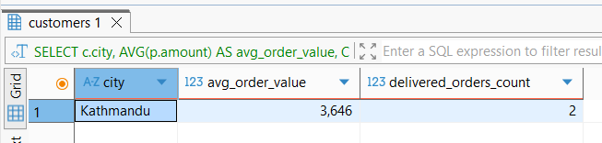

## 2. **Category Mix per Customer**     - For each customer, list categories purchased and the **count of distinct orders** per category. Order by customer and count desc.

**SELECT**

*c*.customer_id,

*c*.full_name,

*p*.category,

**COUNT**(**DISTINCT** *o*.order_id) **AS** *order_count*

**FROM** training_ecom.customers *c*

**JOIN** training_ecom.orders *o* **ON** *c*.customer_id = *o*.customer_id

**JOIN** training_ecom.order_items *oi* **ON** *o*.order_id = *oi*.order_id

**JOIN** training_ecom.products *p* **ON** *oi*.product_id = *p*.product_id

**WHERE** *o*.status != 'cancelled'

**GROUP** **BY** *c*.customer_id, *c*.full_name, *p*.category

**ORDER** **BY** *c*.customer_id, *order_count* **DESC**;

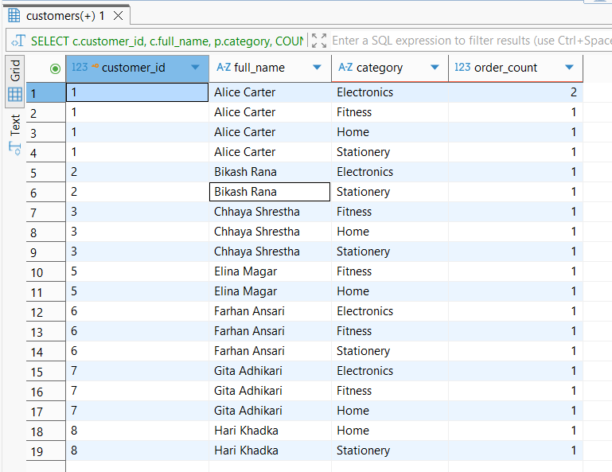

## 3. **Set Ops: Overlapping Customers**     - Split customers into two sets: those who bought `Electronics` and those who bought `Fitness`. Show:       - `UNION` of both sets,       - `INTERSECT` (bought both),       - `EXCEPT` (bought Electronics but not Fitness).

## -- UNION: Customers who bought Electronics or Fitness

**SELECT**

*c*.customer_id,

*c*.full_name

**FROM** training_ecom.customers *c*

**JOIN** training_ecom.orders *o* **ON** *c*.customer_id = *o*.customer_id

**JOIN** training_ecom.order_items *oi* **ON** *o*.order_id = *oi*.order_id

**JOIN** training_ecom.products *p* **ON** *oi*.product_id = *p*.product_id

**WHERE** *p*.category = 'Electronics' **AND** *o*.status != 'cancelled'

**UNION**

**SELECT**

*c*.customer_id,

*c*.full_name

**FROM** training_ecom.customers *c*

**JOIN** training_ecom.orders *o* **ON** *c*.customer_id = *o*.customer_id

**JOIN** training_ecom.order_items *oi* **ON** *o*.order_id = *oi*.order_id

**JOIN** training_ecom.products *p* **ON** *oi*.product_id = *p*.product_id

**WHERE** *p*.category = 'Fitness' **AND** *o*.status != 'cancelled'

**ORDER** **BY** customer_id;

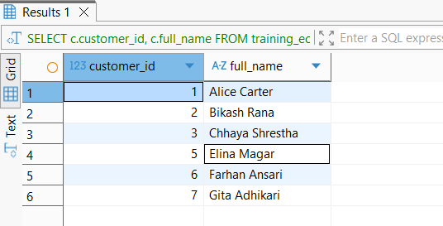

## -- INTERSECT: Customers who bought both Electronics and Fitness

**SELECT**

*c*.customer_id,

*c*.full_name

**FROM** training_ecom.customers *c*

**JOIN** training_ecom.orders *o* **ON** *c*.customer_id = *o*.customer_id

**JOIN** training_ecom.order_items *oi* **ON** *o*.order_id = *o*.order_id

**JOIN** training_ecom.products *p* **ON** *oi*.product_id = *p*.product_id

**WHERE** *p*.category = 'Electronics' **AND** *o*.status != 'cancelled'

**INTERSECT**

**SELECT**

*c*.customer_id,

*c*.full_name

**FROM** training_ecom.customers *c*

**JOIN** training_ecom.orders *o* **ON** *c*.customer_id = *o*.customer_id

**JOIN** training_ecom.order_items *oi* **ON** *o*.order_id = *o*.order_id

**JOIN** training_ecom.products *p* **ON** *oi*.product_id = *p*.product_id

**WHERE** *p*.category = 'Fitness' **AND** *o*.status != 'cancelled'

**ORDER** **BY** customer_id;

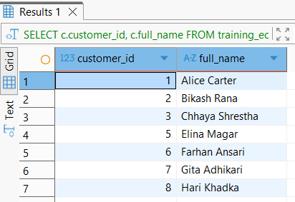

## -- EXCEPT: Electronics but not Fitness

**SELECT**

*c*.customer_id,

*c*.full_name

**FROM** training_ecom.customers *c*

**JOIN** training_ecom.orders *o* **ON** *c*.customer_id = *o*.customer_id

**JOIN** training_ecom.order_items *oi* **ON** *o*.order_id = *o*.order_id

**JOIN** training_ecom.products *p* **ON** *oi*.product_id = *p*.product_id

**WHERE** *p*.category = 'Electronics' **AND** *o*.status != 'cancelled'

**EXCEPT**

**SELECT**

*c*.customer_id,

*c*.full_name

**FROM** training_ecom.customers *c*

**JOIN** training_ecom.orders *o* **ON** *c*.customer_id = *o*.customer_id

**JOIN** training_ecom.order_items *oi* **ON** *o*.order_id = *o*.order_id

**JOIN** training_ecom.products *p* **ON** *oi*.product_id = *p*.product_id

**WHERE** *p*.category = 'Fitness' **AND** *o*.status != 'cancelled'

**ORDER** **BY** customer_id;

